Saboteur Simulator

Analysis and Design Document

Student: Iulia Ungur

**Group: 30235**

Revision History

|  |  |  |  |
| --- | --- | --- | --- |
| **Date** | **Version** | **Description** | **Author** |
| 27/05/2016 | 1.0 | <details> | Iulia Ungur |
|  |  |  |  |
|  |  |  |  |
|  |  |  |  |

Table of Contents

I. Project Specification 4

II. Elaboration – Iteration 1.1 4

1. Domain Model 4

2. Architectural Design 4

2.1 Conceptual Architecture 4

2.2 Package Design 4

2.3 Component and Deployment Diagrams 4

III. Elaboration – Iteration 1.2 4

1. Design Model 4

1.1 Dynamic Behavior 4

1.2 Class Design 4

2. Data Model 4

3. Unit Testing 4

IV. Elaboration – Iteration 2 4

1. Architectural Design Refinement 4

2. Design Model Refinement 4

V. Construction and Transition 5

1. System Testing 5

2. Future improvements 5

VI. Bibliography 5

# Project Specification

The project implements a very simplistic version of the popular Saboteur board game.

# Elaboration – Iteration 1.1

# Domain Model

# Architectural Design

## http://www.mcpressonline.com/articles/images/2002/041014%20-%20Client-Server%20ArchitectureV6--10250400.jpgConceptual Architecture

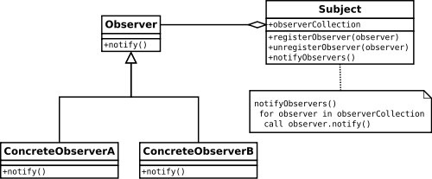

## Package Design

[Create a package diagram]

## Component and Deployment Diagrams

[Create the component and deployment diagrams.]

# Elaboration – Iteration 1.2

# Design Model

# Client

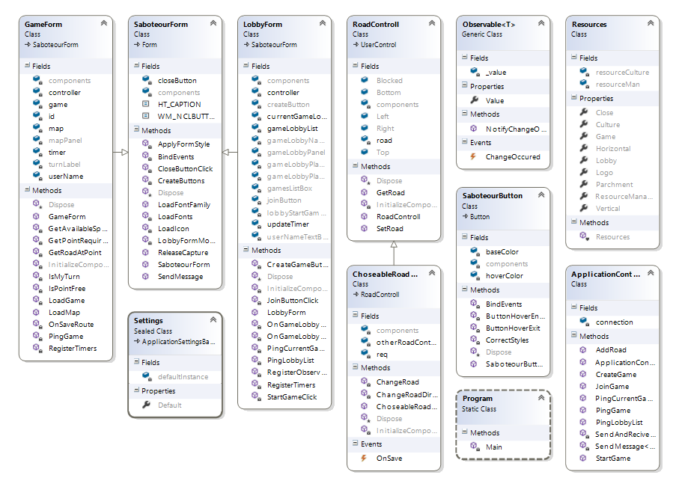

# Common

# 

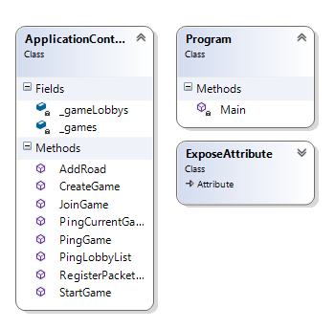**Server**

# Data Model

No data storage will be used in the system

# Unit Testing

# The system has been tested only on the functionality level: every scenario has been manually tested if it works correctly.

# Elaboration – Iteration 2

# Architectural Design Refinement

# Design Model Refinement

No data storage has been used in the system.

# Construction and Transition

# System Testing

The system has been tested only on the functionality level: every scenario has been manually tested if it works correctly.

# Future improvements

The system could be extended on many levels:

It can store information about the users and games in a database (Entity Framework)

A chat room can be implemented

Card extensions – using a special deck of card including: path destroyers and user blockage

# Bibliography

<https://en.wikipedia.org/wiki/Saboteur_(card_game)>

<https://boardgamegeek.com/boardgame/9220/saboteur>

<https://msdn.microsoft.com/en-us/library/ee850490(v=vs.110).aspx>

<http://www.networkcomms.net/>

<https://msdn.microsoft.com/en-us/library/bew39x2a(v=vs.110).aspx>

<http://www.codeproject.com/Articles/1415/Introduction-to-TCP-client-server-in-C>